    
News in the time of self – isolation for the Orthodox Church of the Holy Prophet Elias in Devon
14th June 2020
Prophet Elias News

Our apologies for the fact that a serious computer malfunction in the Editorial Office has meant that this issue has gone out incomplete, later than usual and not up to our normal standard of presentation. The photographs and other items some of you have submitted (for which many thanks) will be included in the next issue.

The Feast of Pentecost

by Fr. Alexander Schmemann (quoted by Father Peter on Pentecost Sunday)

In the Church's annual liturgical cycle, Pentecost is "the last and great day." It is the celebration by the Church of the coming of the Holy Spirit as the end - the achievement and fulfillment - of the entire history of salvation. For the same reason, however, it is also the celebration of the beginning: it is the "birthday" of the Church as the presence among us of the Holy Spirit, of the new life in Christ, of grace, knowledge, adoption to God and holiness.

This double meaning and double joy is revealed to us, first of all, in the very name of the feast. Pentecost in Greek means fifty, and in the sacred biblical symbolism of numbers, the number fifty symbolizes both the fulness of time and that which is beyond time: the Kingdom of God itself. With the descent of the Holy Spirit upon Christ's disciples, the time of salvation, the Divine work of redemption has been completed, the fulness revealed, all gifts bestowed: it belongs to us now to "appropriate" these gifts, to be that which we have become in Christ: participants and citizens of His Kingdom.

At Vespers after the Liturgy of Pentecost, we are invited to kneel. This is our first kneeling since Easter. It signifies that after these fifty days of Paschal joy and fulness, of experiencing the Kingdom of God, the Church now is about to begin her pilgrimage through time and history. It is evening again, and the night approaches, during which temptations and failures await us, when, more than anything else, we need Divine help, that presence and power of the Holy Spirit, who has already revealed to us the joyful End, who now will help us in our effort towards fulfillment and salvation. The joy of Easter has been completed and we again have to wait for the dawn of the Eternal Day. Yet, knowing our weakness, humbling ourselves by kneeling, we also know the joy and the power of the Holy Spirit who has come. We know that God is with us, that in Him is our victory.

Thus is completed the feast of Pentecost and we enter "the ordinary time" of the year. Yet, every Sunday now will be called "after Pentecost" - and this means that it is from the power and light of these fifty days that we shall receive our own power, the Divine help in our daily struggle. At Pentecost we decorate our churches with flowers and green branches - for the Church "never grows old, but is always young." It is an evergreen, everliving Tree of grace and life, of joy and comfort. For the Holy Spirit - "the Treasury of Blessings and Giver of Life - comes and abides in us, and cleanses us from all impurity," and fills our life with meaning, love, faith and hope.

Orthodox Apocalypse: Judgment and Hope for Orthodoxy in the time of Coronavirus
by Rev. Dr. Anastasios Brandon Gallaher and Fr. Richard René
[Extract reprinted with the authors’ permission. The full text can be found at https://publicorthodoxy.org/2020/06/02/orthodox-apocalypse-coronavirus/?fbclid=IwAR1kINJ-iRrb2FCs-9QpG3SbZALitjWhfHwsBtLJJ2x4GgLk7dMA8qiuNPc ]
Coronavirus has descended on our world as an apocalypse, a whirlwind destroying the shelter of our fixed verities, ripping the roofs off our traditions and throwing into the blaze of the sun the hidden sins and fragilities of our institutions.

Yet this apocalypse also acts to reveal hope of glory and redemption through our cooperation with God in fear and trembling, anticipating the age when “God will wipe away every tear…” (Rev. 7:17). It has revealed the quiet but blazing sanctity in Christians who help the vulnerable in their time of need bringing food to the hungry, visiting the lonely at the end of the garden, and providing teaching online to the faithful of all ages. It has borne testimony to the tirelessness of clergy feeding their flocks through an abundance of online services, or simply praying for their flock day in and out secretly in their inner room (Matt. 6:6). It has empowered the laity as the guardians of the holy, calling everyone to make “little churches” in their own homes.

These efforts force us to ask difficult questions. What does it mean to attend a liturgical service? Is virtual communion possible? Might we obtain absolution through confessing our sins to one another? Might someone become a member of the Body without even entering a physical church? In short: where and what is the Church? Coronavirus forces us to raise and discuss such issues, only silently whispered up until now in Orthodoxy. Finally, with our social fabric shredded, Orthodox communities and leaders are now grappling with social and ethical issues that we have previously ignored, looking to renew evangelism, catechesis, and outreach to the whole world through renewed social teaching.

In this sense, Coronavirus is an apocalypse, a revelation both of judgement and of hope. It calls us to be creative as the Church, the Body of the Living Christ, to share the wealth of our tradition in this moment of decision (krisis) thrust on us by late modernity. To answer this calling, we must emerge from our communal, spiritual, moral lockdown. As one slogan making the rounds of the internet puts it, “We won’t return to normality, because normality was the problem.” Normality claims that we can live in our own solitudes, untouched by the susceptibilities of others, and that is the problem. If, however, we can allow this apocalypse to reveal to us that all humanity is united in a common, universal vulnerability, iconizing in the fight against Corona our wounded Bridegroom transfixed with nails, then we can be transformed. We can attain to the likeness of vulnerability of Jesus Christ crucified like Ignatius the God-bearer who said of his martyrdom, ‘Let me imitate the Passion of my God’ (Ignatius, Romans 6:3). In this way, we can, through God’s gracious revelation of judgement and hope, participate in transforming the crucifixion of this world by the pandemic into a resurrected life.

Rev. Dr. Anastasios Brandon Gallaher is Senior Lecturer of Systematic and Comparative Theology at the University of Exeter. Fr. Richard René is a Ph.D. student at the Univesity of St. Michael’s College, Toronto School of Theology.

June 17th – Saint Nectan of Hartland
Saint Nectan was a 5-6th Century hermit and martyr, eldest of twelve sons and twelve daughters of the South Welsh King Brychan, many of whom also became saints. Inspired by tales of the Desert Fathers, Nectan set sail from Wales and landed at Harland in North Devon, where he established the hermitage where he spent the rest of his life. He was murdered by cattle thieves in 510. Local tradition tells that they cut off his head, which he picked up and carried back to his cell, leaving a trail of blood which has been marked ever since by swathes of foxgloves flowering around the day of his martyrdom.
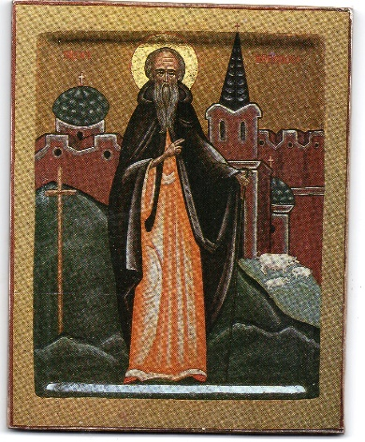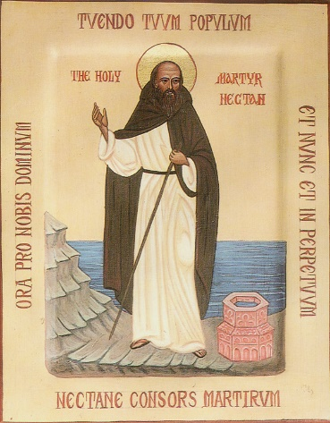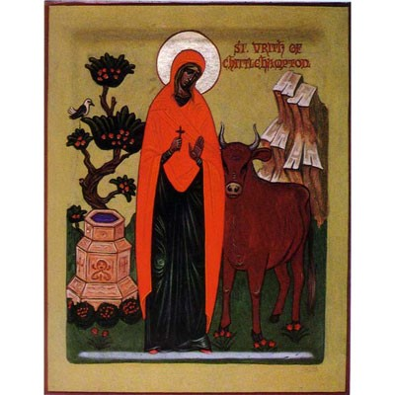
Saint Nectan is one of three North Devon saints who were for many years commemorated by the Combe Martin parish with a weekend pilgimage to the sites of their hermitages. The others were Saint Brannoc of Braunton (tutor to King Brychan’s children before settling in Devon – his feastday is June 26th) and the Virgin Martyr Urith of Chittlehampton (July 8th).

June 20th - Saint Nicolas Kabasilas

14th C Byzantine lay theologian, best known for his Commentary on the Divine Liturgy and The Life in Christ.

‘Under normal circumstances food is changed into the person who consumes it: fish, bread and the like become human flesh and blood. But in holy communion the exact opposite happens. The Bread of Life himself changes the person who eats, assimilating and transforming him into himself.
See in what sense the Kingdom of Heaven is within us.’
From The Life in Christ

A domestic feast and a much-travelled icon

It seems strangely appropriate celebrating Pentecost in lockdown. For all that it commemorates ‘so great a mystery’, this is a curiously domestic feast. If at Easter we celebrate Christ taking us across ‘from earth to heaven’, Pentecost finds us definitely back on earth – but not alone. When we pray to the Holy Spirit ‘come and abide in us’, we may think first of all of the continuity implied, the ‘abiding’ presence of the Spirit, which of course is also quite true. But this translation obscures the fact that the petition uses the exact words in which the Fourth Gospel speaks of the coming of God the Word in the flesh (Jn 1:14). We are asking the Holy Spirit in turn to ‘dwell among us’.
Yet ‘dwell among us’ still does not quite capture the message of this year’s Pentecost. It had never struck me in quite this way before; but at a time when welcoming any human guest into our homes is still a wistful memory, we are inviting the Holy Spirit to come and stay.
It is a remarkable experience to celebrate the coming, the moving-in of the Holy Spirit amidst all the trappings of one’s domestic life. Here and now, when we cannot visibly constitute the gathered Church, the grace of the Holy Spirit has brought us together. I join in the Liturgy standing before the eclectic mix of saints whose icons populate our icon-corner; but through the icons and many other items pressed into service for participation in worship from home, I am connected also with so many others I have known, reminded that they too are present in the ecclesial gathering. There is icon of the Mother of God given us by Metropolitan Anthony, with which we were blessed at our wedding in St Anne’s thirty years ago, in the presence of our dearest friends and relations – some of whom will be reading this. The incense from Patmos, a gift from a Cypriot friend who had made a life-changing visit to the women’s monastery there. The ceramic home censer which I had forgotten I had; I had bought it for my mother perhaps 45 years ago because I liked the colour and interesting shape, with no idea what it was for... The service books book-marked with postcards from long-departed friends, so that as I hear their names over a wavering internet connection to the commemorations of Soul Saturday, my fingers can touch those names signed by their hand. And the seventeenth-century Holy Trinity icon, whose story I want to tell here.
This icon was given to Fr Vladimir Theokritoff by an Englishman who had acquired it when in Russia, apparently as a diplomat. After the Second World War, he wanted it to be in Orthodox hands and so sought out the priest of the Russian church in London. I have a portion of his explanatory letter, which I transcribe exactly:
… While in Kubyshev (Samara) every afternoon during the summer found me wandering down to ‘Matuski Volga’ for a row across to the golden sands the other side for a swim and a laze in the sun.
One day mid-1942, returning up the steep bank back to the embassy, I saw an old grey-haired woman struggling with two large water containers, and I immediately offered my assistance. Rather taken aback, she smiled and silently allowed me to relieve her and carry them to the top of the hill. Whereupon she said, ‘All men are dead in Russia!’ A bit puzzled I replied, ‘No! Surely they are at the front?’ - but she shook her head and would not agree with my observation.
However, from this small beginning, our acquaintance grew, and during the following winter I paid her regular visits, in her humble yet very neat clean and tidy room, furnished with an old fashioned dressing table, two armchairs, couch samovar and aspidistra – all very Victorian.
It appears that her husband, an officer in the ‘White Army’, had been shot during the revolution, and she had been ‘moved’ to Samara. We ‘ran into religion’ as a subject for discussion very soon and her old Tolstoyan bible was a source of great interest to me. It was during one of these interludes that she observed my desire to possess an old icon, and told me that there were seven in her possession which had been owned by branches of her husband’s family and that I was welcomed to take my selection of four which she said there was no hope of passing them on to descendants of any kind.
After picking ‘Holy Trinity’ it was with considerable difficulty before I was able to make her accept 500 roubles but with some coaxing she relented. The chief reason for this I think was that on every occasion of my visits I always had a surprise parcel of food, such things as butter sugar and tea, which were unobtainable in the shops. Tears of joy often flowed when she opened these surprise packets.
The icon was painted in St Petersburg between 1650-1700 and had been handed down to one of her great uncles. This information was confirmed by the keeper of the Vatican art museum which [sic] I was working there in 1945.
The route that this icon travelled to the UK was – Moscow – Tehran Damascus Beirut Jerusalem Cairo Rome by air and thence by sea from Naples via Gib to Liverpool.
Incidentally the only name I ever learnt of this old lady was ‘Alexandrovna’ and her home then was in Sadova Street...

My husband treasured this icon, and I think felt the humbling responsibility of being its keeper. Often he would take it to church for Pentecost and ask the priest to take it into the altar during the Liturgy; but this year, the Liturgy has come to it.
The Holy Spirit who 'moves in' with us is at the same time everywhere present, and also 'holding together the whole institution of the Church'. This means that he is not simply present in our own hearts even when we are 'distanced' from other people. He also reveals our unity with all, the unbreakable bond of peace that unites us: He reveals the whole Church from which we are inseparable wherever we are.
Elizabeth Theokritoff

Private Prayer at Saint Anne's
The government has announced that places of worship may open for private prayer as from Monday 15th June. If anyone would like to make use of this opportunity, we will happily arrange for Saint Anne's to be open either on Saturday evening between 6 and 7 or on Sunday morning between 11 and 12. We will however need to know in advance, as someone will need to open the church and to stand at the gate with sanitising equipment to protect the residents in the courtyard. Please ring or email me (01837 82796 or martinolsson827@btinternet.com) by the previous Friday evening to make an arrangement.
Martin Olsson - Acting Churchwarden

