News in the time of self –isolation for the Orthodox Church of the Holy Prophet Elias in Devon
30th August 2020
Prophet Elias News

On 1st September we Celebrate the Beginning of the New Church Year, and Observe a Day of Prayer for the Protection of the Environment

To Commit a Crime Against the Natural World is a Sin
by Ecumenical Patriarch Bartholomew I

People of all faith traditions praise the Divine, for they seek to understand their relationship to the cosmos. The entire universe participates in a celebration of life, which Saint Maximos the Confessor described as a “cosmic liturgy”. We see this cosmic liturgy in the symbiosis of life’s rich biological complexities. These complex relationships draw attention to themselves in humanity’s self-conscious awareness of the cosmos. As human beings, created “in the image and likeness of God” (Genesis 1:26), we are called to recognise this interdependence between our environment and ourselves. In the bread and wine of the Eucharist, as priests standing before the altar of the world, we offer the Creation back to the Creator in relationship to Him and to each other.

Indeed, in our liturgical life, we realize by anticipation the final state of the cosmos in the Kingdom of Heaven. We celebrate the beauty of creation and consecrate the life of the world, returning it to God with thanks. We share the world in joy as a living mystical communion with the Divine. Thus it is that we offer the fullness of creation at the Eucharist, and receive it back as a blessing, as the living presence of God.

Moreover, there is also an ascetic element in our responsibility towards God’s creation. This asceticism requires from us a voluntary restraint in order for us to live in harmony with our environment. Asceticism offers practical examples of conservation. By reducing our consumption – in Orthodox terms encratia, or self-control - we come to ensure that resources are also left for others in the world. As we shift our will, we demonstrate a concern for the Third World and developing nations. Encratia frees us of our self-centred neediness, that we may do good works for others. We do this out of a personal love for the world around us. We are called to work in humble harmony with creation and not in arrogant supremacy against it. Asceticism provides an example whereby we may live simply.

Asceticism is not a flight from society and from the world, but a communal attitude of mind and way of life that leads to the respectful use, and not abuse, of material goods. Excessive consumption may be understood to issue from a worldview of estrangement from self, from land, from life and from God. Excessive consumption leaves us emptied, out of touch with our deepest self. Asceticism is a corrective practice, a vision of repentance. Such a vision will lead us from repentance to return, the return to a world in which we give to as well as take from creation.

Extract from an essay in Moral Ground: Ethical Action for a Planet in Peril
Eds Kathleen Moore and Michael Nelson: Trinity UP San Antonio 2010

For Ev’ry Thing that Lives is Holy

William Blake (1750 – 1827)

The World as Gift and Sacrament

The whole world ought to be regarded as the visible part of a universal and continuing sacrament, and all man’s activities as a sacramental, divine communion.

Because man is unable to give God anything except that which he has already received from God, man learns to perceive the world as a gift and sacrament by sacrificing something in the world for God’s sake, as a sign of his grateful love, and as the vehicle of this love. God for his part returns to man what man has sacrificed in the form of fresh gifts, containing a new manifestation of his love, in new and repeated blessing. ‘Grace for grace.’ And so an unbroken interchange between God and man in man’s use of the world takes place, an ever-renewed and growing mutuality of love. The more man discovers the beauty and the higher use of created things, and the greater the gratitude and love with which he responds to God, the more God responds with still greater love and blessing, because man is in the position to receive it.

Man puts the seal of his understanding and of his intelligent work on to creation, thereby humanizing it and giving it back to God. He actualizes the world’s potentialities. Thus the world is not only a gift but also a task for man.

Fr Dumitru Staniloae; from The World as Gift and Sacrament of God’s Love in Sobornost 5.9 (1969)

Right Enjoyment of the World

Your enjoyment of the world is never right, till every morning you awake in Heaven; see yourself in your Father’s Palace; and look upon the skies, the earth, and the air as Celestial Joys: having such a reverend esteem of all, as if you were among the Angels.

You never enjoy the world aright, till the Sea itself floweth in your veins, till you are clothed with the heavens, and crowned with the stars: and perceive yourself to be the sole heir of the whole world, and more than so, because others are in it who are every one sole heirs as well as you. Till you can sing and rejoice and delight in God, as misers do in gold, and kings in sceptres, you never enjoy the world.

Till your spirit filleth the whole world, and the stars are your jewels; till you are as familiar with the ways of God in all Ages as with your walk and table: till you are intimately acquainted with the shady nothing out of which the world was made: till you love men so as to desire their happiness, with a thirst equal to the zeal of your own; till you delight in God for being good to all: you never enjoy the world. Till you more feel it than your private estate, and are more present in the whole hemisphere, considering the glories and the beauties there, than in your own house: Till you remember how lately you were made, and how wonderful all was when you came into it: and more rejoice in the palace of your glory, than if it had been made but today morning.
Thomas Traherne (1637 – 1674) : Centuries I 28-30
This Week We Celebrate

On Monday August 31st – Saint Aidan of Lindisfarne, Apostle to the Northumbrians (d 651)
Remembering our dearly loved and much missed Aidan – May his Memory be Eternal!

On Tuesday September 1st – Church New Year – Day of Prayer for the Protection of the Environment
We pray for all students and their teachers returning to school and college this week.

On Friday September 4th – The Holy Prophet and God-Seer Moses
We wish Moses K a Happy Feast and Many Years!

On Saturday September 5th – The Prophet Zachariah and Righteous Elizabeth, parents of St John the Baptist
We wish Alice, Elizabeth D, Elizabeth T and Lily a Happy Feast and Many Years!

From the Akathist Glory to God for All Things

For many years it has been a tradition in our parish to sing this beautiful Akathist on the eve of the Day of Prayer for the Protection of the Environment. It was composed by Metropolitan Tryphon (Prince Boris Petrovich Turkestanov) +1934 – but is frequently attributed to Father Gregory Petrov, after a copy was found among his effects when he died in a Soviet prison camp in 1940. The title is taken from the words of Saint John Chrysostom as he lay dying in exile. The full text can be found at
http://saintjonah.org/services/thanksgiving.htm

Ode 2
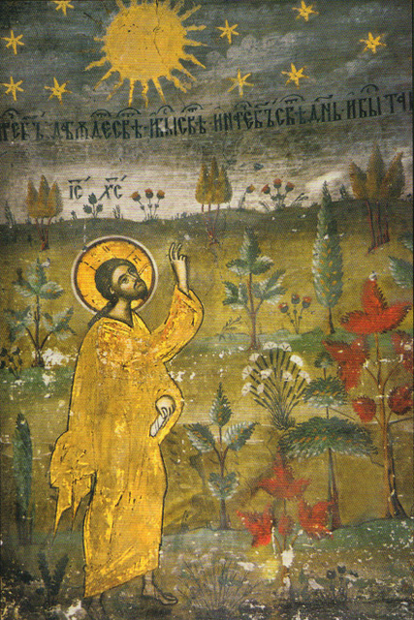
O Lord, how lovely it is to be Your guest. Breeze full of scents — mountains reaching to the skies — waters like a boundless mirror, reflecting the sun’s golden rays and the scudding clouds. All nature murmurs mysteriously, breathing depths of Your tenderness. Birds and beasts of the forest bear the imprint of Your love. Blessed is our mother the earth, in her fleeting loveliness, which wakens our yearning for happiness that will last forever in the land where, amid beauty that grows not old, rings out the cry: Alleluia!

Ikos 2
You have brought me into life as if into an enchanted paradise. We have seen the sky like a chalice of deepest blue, where in the azure heights the birds are singing. We have listened to the soothing murmur of the forest and the melodious music of the streams. We have tasted fruit of fine flavour and the sweet-scented honey. We can live very well on your earth. It is a pleasure to be your guest.
Glory to You for the feast-day of life.
Glory to You for the perfume of lilies and roses.
Glory to You for each different taste of berry and fruit.
Glory to You for the sparkling silver of early morning dew.
Glory to You for the joy of dawn’s awakening.
Glory to You for the new life each day brings.
Glory to You, O God, from age to age.

Ikos 12
What sort of praise can I give You? I have never heard the song of the cherubim, a joy reserved for the spirits above. But I know the praises that nature sings to You. In winter, I have beheld how silently in the moonlight the whole earth offers You prayer, clad in its white mantle of snow, sparkling like diamonds. I have seen how the rising sun rejoices in You, how the song of the birds is a chorus of praise to You. I have heard the mysterious murmurings of the forests about You, and the winds singing Your praise as they stir the waters. I have understood how the choirs of stars proclaim Your glory as they move forever in the depths of infinite space. What is my poor worship? All nature obeys You, I do not. Yet while I live, I see Your love, I long to thank You, pray to You, and call upon Your Name:

Glory to You, giving us light.
Glory to You, loving us with love so deep, divine, and infinite.
Glory to You, blessing us with light, and with the host of angels and saints.
Glory to You, Father All-Holy, promising us a share in Your Kingdom.
Glory to You, Holy Spirit, Life-giving Sun of the world to come.
Glory to You for all things, holy and most merciful Trinity.
Glory to You, O God, from age to age.

And God saw every thing that he had made, and, behold, it was very good.

Genesis 1: 31

A day in the land of St Morwenna
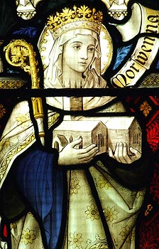
One of our days off last week was to Morwenstow, about half way between Hartland Point and Bude. Not much is known about St Morwenna but she was sister of St Nectan of Hartland and of St Tydfil, mentioned in last week’s newsletter, and is sometimes portrayed as teaching children to read. Morwenstow as a settlement amounts to very little: a 13th century pub, a farm and a couple of houses where we parked and a bit further on the church and another farm, where they serve, according to the notice, 13th century farmhouse teas – an historical treat to look forward to at the end of our walk!

We set off down a track and as we got nearer to the cliffs the wind got stronger. Out at sea white horses raced across blue-grey water, but low tide meant no dramatic waves crashing against the jagged rocks of this most inhospitable of coasts. We joined the coastal footpath heading north soon finding a sign to Hawker’s hut. A narrow path wound down the cliff to a small ledge with a hut just big enough for two made of what looked like planks of drift wood. The Reverend R S Hawker was vicar of Morwenstow in the 19th century and was responsible for the introduction of Harvest Services and the ceremony of crowning the May Queen. Back up the cliff the path crossed fields yellowed with coltsfoot then as it dipped down into the Morwenstow valley the land juts out in a very unprotected manner. Martin and I decided against that route as the wind threatened to knock us off our feet. Instead there was a path across a field with a much gentler slope. The opposite steeper and higher slope was covered with brilliant jewels of magenta heather and golden gorse – a stunning view for a picnic.

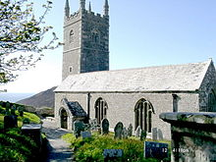
At the bottom of the field we headed seaward. At the cliff edge the stream forms little pools before disappearing over the cliff to the shore some 30 feet below. There is a way down to St Morwenna’s well from here – but no markers and our google searches suggested should only be attempted with proper climbing gear. We didn’t visit! Out at sea I caught a glimpse of a whale’s blow spout. We retraced our way along the path bordered by any amount of wild flowers - thrift, scabious, tiny yellow potentilla, more gorse, all of great interest to the myriad butterflies – then through low growing trees before reaching the ‘village’. In the large churchyard, we found 8 or so war graves - one World War I, one 1952 which I presumed was Malaysia and the rest World War II – and a replica of the ship’s head from the wreck of the Caledonia below which the captain and his crew are buried. Inside, the church is spacious with an embroidery telling the story of St Morwenna, unfortunately hung so high that without standing on the pews (not in my muddy wellingtons) I couldn’t see it properly. There were various old wood carvings, including 15th century pew ends, and an ancient stone font. The church was rebuilt in Norman times but the font is older, showing Saxon designs. It is still used for baptisms with the water coming from the nearby St John’s Well. Emerging through the lych gate and onto the village green we saw the farmhouse serving the aforementioned teas. Now, I had been wondering what would constitute a 13th century farmhouse tea all during our walk. Dear Reader, from our experience on Thursday, it would appear that the people of the 1200s enjoyed afternoon teas in much the same way we do today – choice of teas, scones, cream, jam and various cakes. The only difference being the take away paper cups and plates (Covid precautions).
A delicious end to a day walking in the footsteps of St Morwenna.
Celia Olsson

